 | Nebraska VR  Nebraska Department of Education | State Office • PO Box 94987  Lincoln, NE 68509-4987
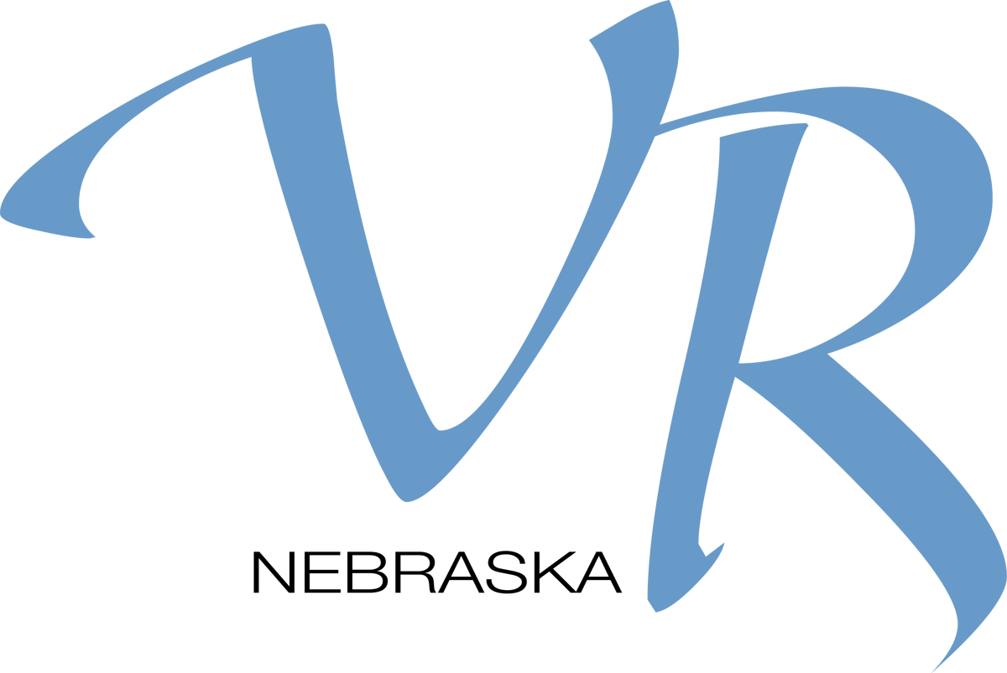
11/2018

Video Conference Participant List

Training Date: Contact Hours:
(actual training time, do not include breaks )
Title of Event:

Presenter Name:

Participant:

Email the completed event sheet to Paige Rose paige.rose@nebraska.gov

